Lecture 11
CHEMISTRY OF NUCLEIC ACID I
Introduction
Nucleic acids are the most important macromolecules in all living things because it is the genetic material responsible for the transfer of genetic information from one generation of organisms to another. The traits we shared with our parents are due to the genes inherited from them. These include but not limited to physical appearance, colour of skin, size of eye balls, intelligence etc.

Nucleic Acids
Nucleic acids are linear polymers of nucleotides i.e. nucleotides are the monomeric units of nucleic acids. Each nucleotide has three components: a five-carbon monosaccharide, a nitrogen-containing cyclic compound (base) and a phosphate group.

Five carbon Sugars – The five carbon sugars are known as pentoses. Two different five-carbon sugars are employed in the construction of nucleic acids; they are ribose and deoxyribose sugars. The only difference between them is the absence of oxygen on the 2’carbon atom of deoxyribose sugar.
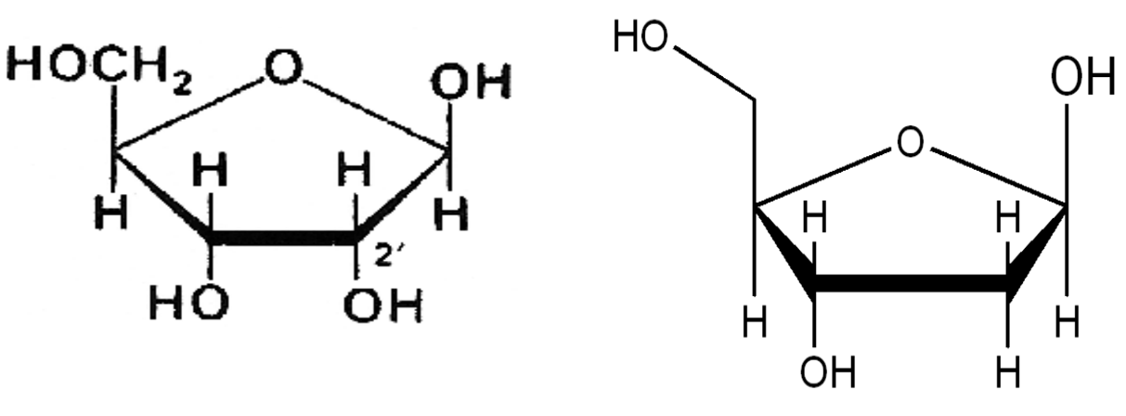
Figure 1: Structures of ribose sugar and Deoxyribose sugar.

1. Nitrogenous bases – The nitrogenous bases employed in the construction of nucleic acids are members of two classes of nitrogen containing compounds known as purines and pyrimidines. Purine has 2 derivatives in nucleic acids (Adenine and Guanine) usually represented by letters A and G. Pyrimidine has 3 derivatives in nucleic acids (cytosine, uracil and thymine) usually represented by capital letters C, U, T. Thymine is present only in DNA molecules while uracil is present only in RNA.
Adenine, Guanine and cytosine bases are present in both DNA and RNA. These nitrogenous bases are the key components of nucleic acid because genetic information is stored in the sequence of bases along the DNA strands. Every time a cell divides, the information is passed along to the new cells.
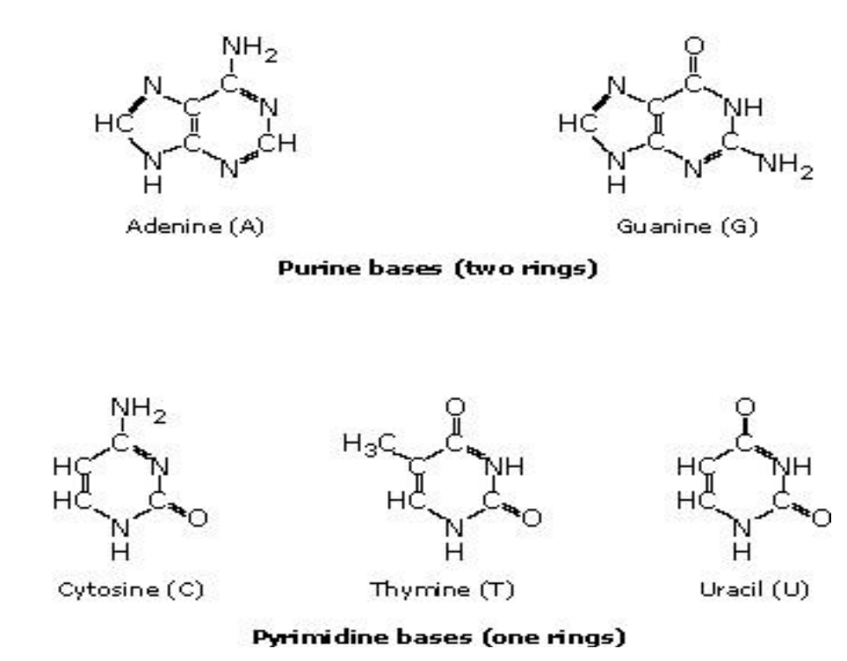
Figure 2: The Structures of Purine and Pyrimidine bases.

2. Phosphate Group – It is a very important component of nucleic acids. It serves as the link between 2 sugar molecules or nucleotides in polynucleotides. The phosphate group is a strong acid in solution; this explains why DNA and RNA are called acids. It is also responsible for the negative charges on DNA and RNA at physiological pH.
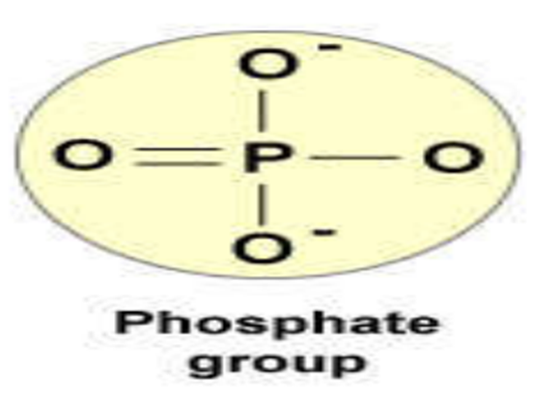
Figure 3: The phosphate group.

The Nucleosides
Nucleosides – Ribose or deoxyribose Sugar + Nitrogenous Base. The combination of ribose or deoxyribose and one of the 5 bases produces a nucleoside. They are linked via a covalent β-N-glycosidic bond.
Nucleosides present in RNA are Adenosine, guanosine, cytidine and uridine.
Nucleosides present in DNA are deoxyadenosine, deoxygyanosine, deoxycytidine and deoxythymidine or thymidine usually abbreviated as A, G, C and T. While the nucleotides present in RNA are represented by A, G, C, U.
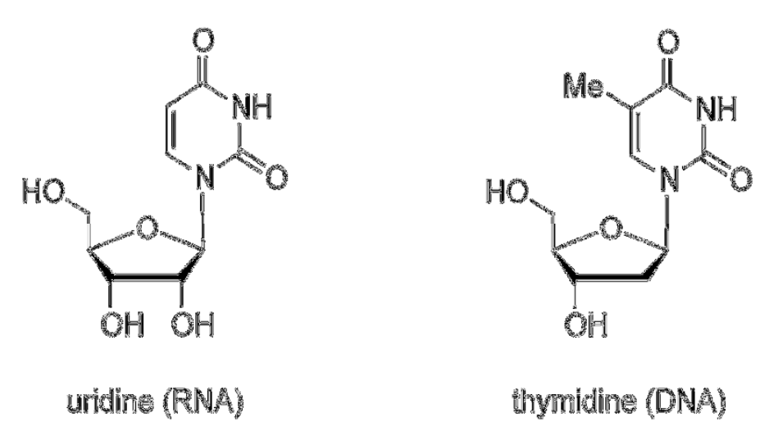
Figure 4: The Structures of 2 Nucleosides, Uridine and Thymidine.

The Nucleotides
Nucleotides are phosphrylated nucleosides (nucleosides + phosphate) or sugar + base + phosphate. Each nucleotide is a 5-monophosphate ester of a nucleoside. The PO₄ group is attached to the hydroxyl group of pentose sugar by an ester linkage, usually OH group on carbon 5, 3 or 2.

Types of Nucleotides
i. Monophosphate – Nucleotides containing only one phosphate molecule
a. AMP – Adenosine monophosphate
b. GMP – Guanosine monophosphate
c. UMP – Uridine monophosphate
ii. Diphosphates and Triphosphates contain two and three molecules of phosphate respectively. Examples of diphosphate nucleotides are ADP, GDP, UDP while ATP, GTP and UTP are examples of triphosphate nucleotides.
iii. Cyclic nucleotides – In cyclic nucleotides, a PO₄ molecule esterifies two OH molecules on carbon 5 and carbon 3 or carbon 3 and 2 (RNA) small letter C is usually added to denote cyclic nucleotide e.g. 3; 5¹ cAMP (3¹, 5¹ cyclic Adenosine monophosphate), 3¹, 5¹ c-GMP is called 3¹, 5¹ cyclic Guanosine monophosphate.
iv. Polynucleotides- The 3¹ OH of the pentose of a mononucleotide esterifies the 5¹ phosphoryl group of the 2nd mononucleotide to form a dinucleotide. The bond between two nucleotides in polynucleotides is known as 3¹, 5¹ phosphodiester bond. The next nucleotide joins the existing polynucleotide through its free 3¹-OH group.
Each end of a nucleotide polymer (polynucleotide) is distinct; one end has a free 5¹ Phosphate while the other end has a free 3¹-OH group, by convention the nucleotides or base sequence is written in 5¹ to 3¹ -direction, therefore polynucleotides are called directional macromolecules.
DNA and RNA are long linear polymers called nucleic acids that carry information in a form that can be passed from one generation to the next. Genetic information is stored in the sequence of bases along a nucleic acid chain.
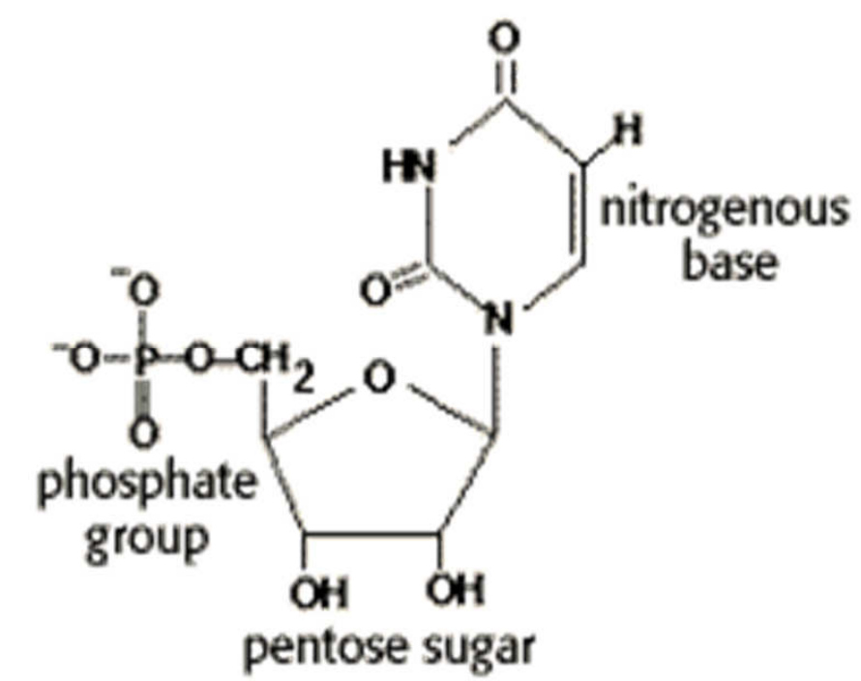

Figure 5: Structure of Ridine Monophosphate.

